ASSIGNMENT -01
APACHE HIVE
NAME: Chandana K T
USN:4GW23CI009
Scenario
A global retail company stores transaction records in flat CSV files on HDFS. The business intelligence team requires structured SQL access to analyze revenue patterns across store categories.
Problem Statement
Create an external table in Hive mapping to raw transaction data stored on HDFS. Write HiveQL queries to clean missing data, aggregate total sales revenue, and calculate the average order value per product category.
Apache Hive & Hadoop
Apache Hive is a data warehouse and data analysis tool built on Hadoop. It provides a SQL-like language called HiveQL to query and analyze data stored in HDFS.
Apache Hadoop is an open-source framework used for distributed storage and processing of large datasets. It uses components such as HDFS, MapReduce, and YARN to manage and process big data.
Docker
Docker is used to provide a consistent and isolated environment for running applications such as Hadoop and Apache Hive. In our project, Docker can help run Hive in a Linux-based container because the Apache Hive installation we have uses Linux shell scripts rather than Windows .cmd files. This avoids many Windows configuration and compatibility problems and makes it easier to set up Hadoop, HDFS, and Hive together. Thus, Hadoop provides storage and processing, Hive performs SQL-like data analysis, and Docker provides the environment to run these tools smoothly.
Workflow
Docker Desktop → Hadoop/HDFS → Transaction CSV → Apache Hive → External Table → Data Cleaning → HiveQL Aggregation → Revenue & Average Order Value.
Docker-Compose.yml
The Docker Compose workflow uses Docker Desktop to run a Hadoop and Apache Hive environment through separate containers. The NameNode manages the HDFS file system, while the DataNode stores the actual transaction data. Apache Hive runs through the HiveServer2 container and provides HiveQL for querying the data stored in HDFS. The transaction CSV file is uploaded to HDFS, an external Hive table is created over the data, and HiveQL queries are used to clean missing records, calculate total sales revenue, and determine the average order value for each product category.

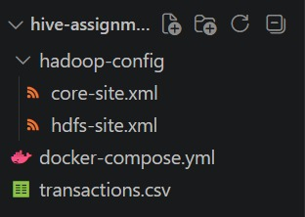
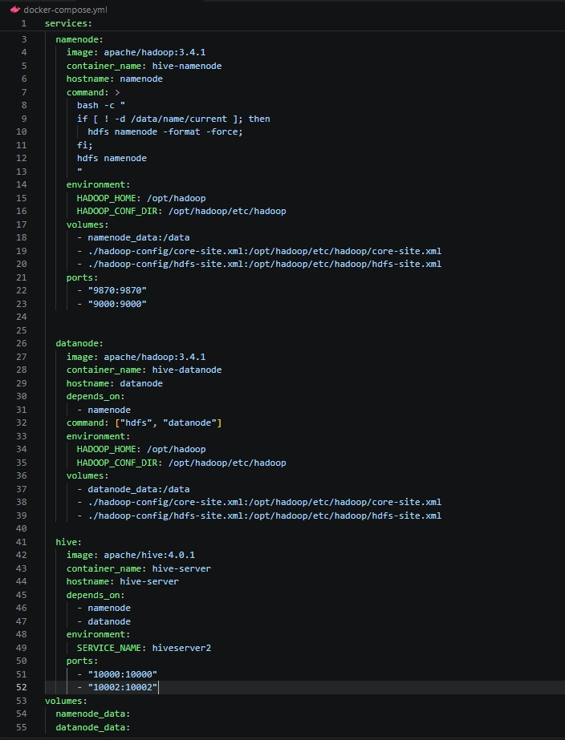
Transaction.csv
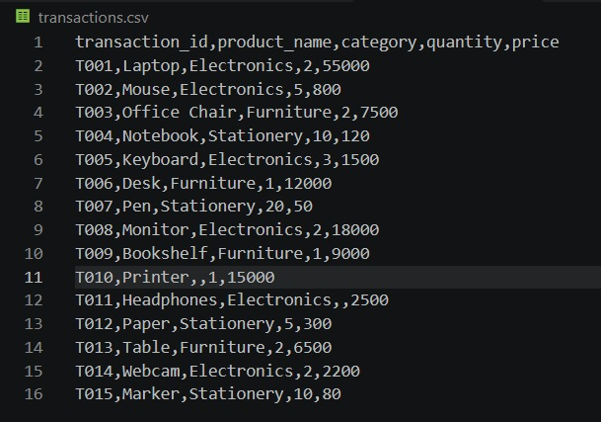
1.To check docker status
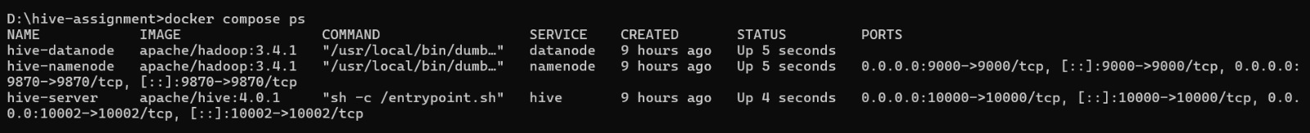
2.Command Line Interface (CLI)
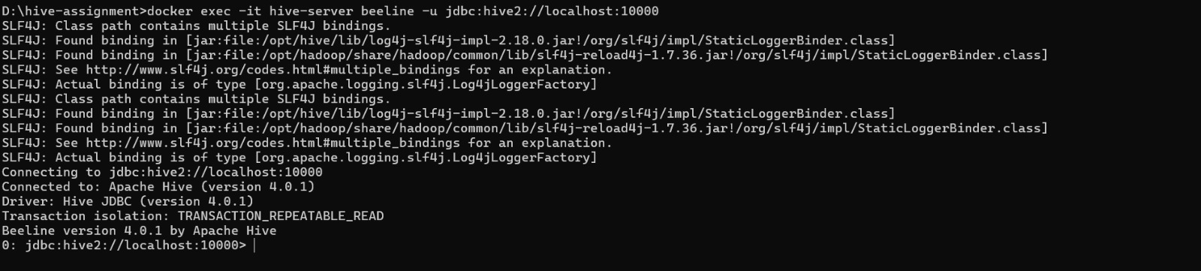
3.To create new database
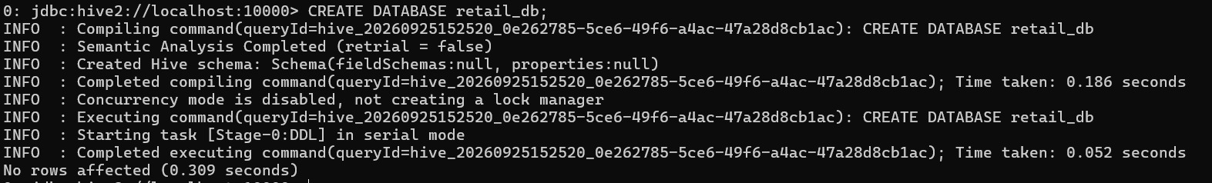

4.To create External table
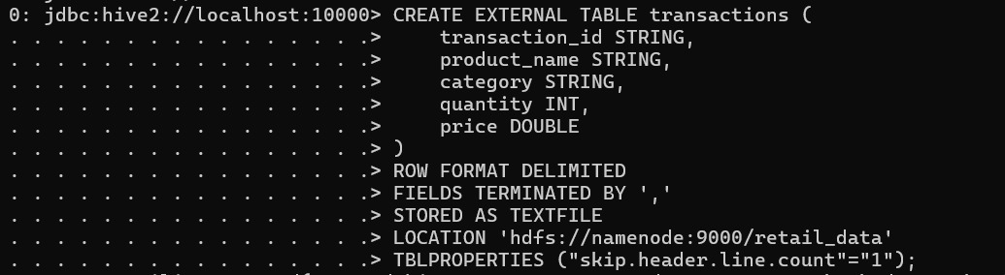
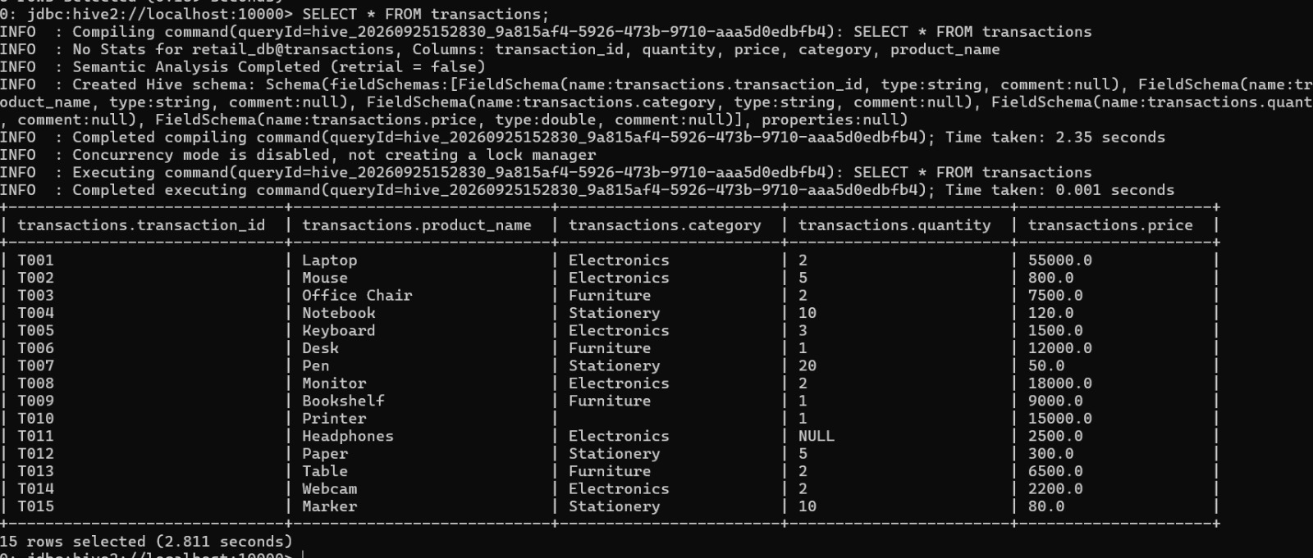
5.Identifying the missing values and cleaning the table
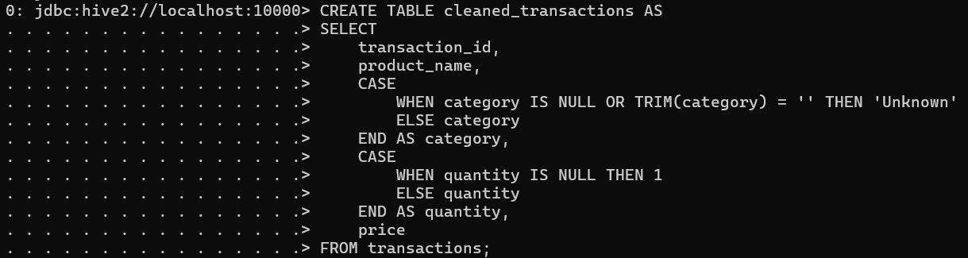
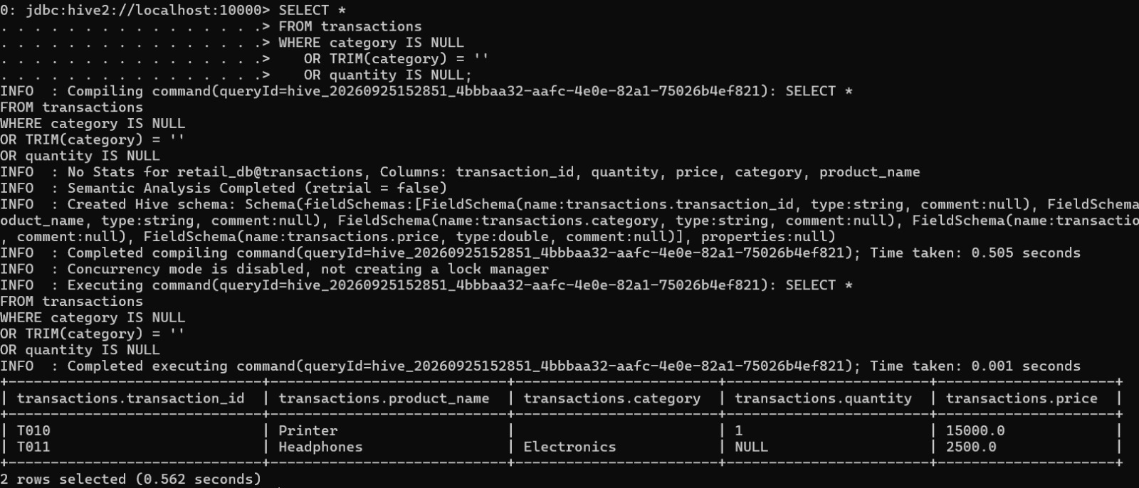

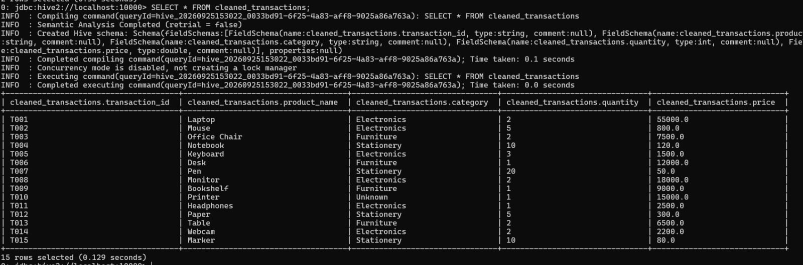
6. Calculate total sales revenue
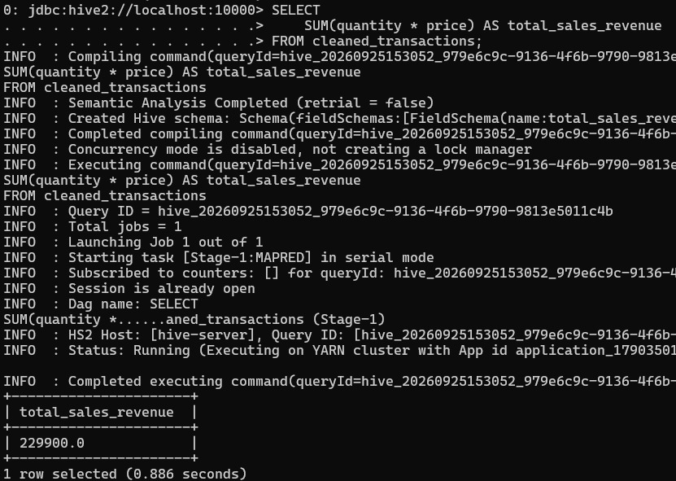

7.Calculate average order value by category
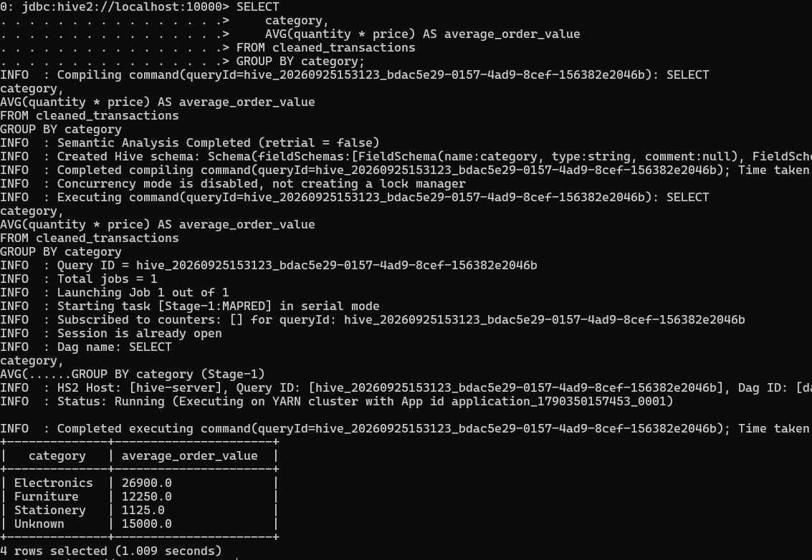
Conclusion
This assignment successfully demonstrates the use of Apache Hadoop, HDFS, Apache Hive, and Docker for data engineering. Transaction data is stored in HDFS and analyzed using an external Hive table and HiveQL queries. Missing data is cleaned, and total sales revenue and average order value are calculated for each product category. Docker provides a consistent environment for running the required technologies, making the overall data analysis workflow easier to manage.

